Cylindrical gauge visual for representing the data in cylinder. It’s mainly used for showing water ratio in the container.

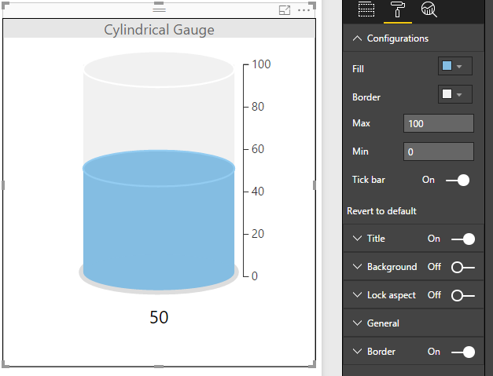

Configurations:

1. Fill: To set color of inner part of the cylinder (e.g. water color)
2. Border: To set border color of cylinder (e.g. container color)
3. Max: To set maximum threshold of cylinder
4. Min: To set minimum threshold of cylinder
5. Tick bar: To enable or disable the cylinder labels (indicators)